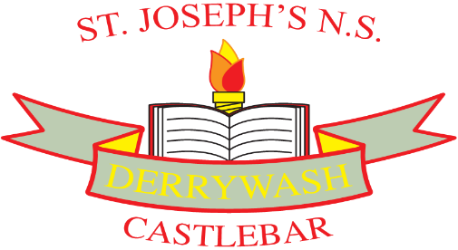

St. Joseph’s National School, Derrywash
HEALTHY LUNCH POLICY
As part of the Social, Personal and Health Education (S.P.H.E.) Programme, we encourage children to become more aware of the need for healthy food in their lunch boxes.
Aims: 1. To promote personal development and well-being of the child.
2. To promote the health of the child and provide a foundation for healthy living in all its aspects.
Objectives: 1. To enable the child to appreciate the important of good nutrition for growing, developing and staying healthy.
2. To enable the child to accept some personal responsibility for making wise food choices and adopting a healthy, balanced diet.

Healthy lunches can;
- Help improve performance and concentration in class
- Can meet childrens’ needs for growth and development
- Encourage good eating habits for life

Lunch Packaging and Recycling:
In accordance with our Green School’s Programme, we ask that pupils;
- Use recyclable food and drinks containers
- Recycle compost items in the compost bin
- Take home any packaging which non-recyclable.

Lunch is an important meal for school-going children. It should provide one third of their
recommended daily allowance of nutrients without being high in fat, sugar or salt. It should also provide dietary fibre.

The following guide is designed to help you provide quick, appetising and nutritious lunches for your children;
Breads/Alternatives  Bread/Rolls/Wraps/Pitta breads (wholemeal variety)  Rice (brown)  Pasta (wholemeal)  Scones (wholemeal)  Crackers / Crispbreads | Meats/Alternatives  Lean Meat (turkey/ham)  Chicken  Tinned fish (e.g. tuna)  Cheese  Eggs
Fruit & Vegetables  Apples, Banana, Oranges  Dried fruit, plums, pineapples  Grapes, Cucumbers, tomatoes,  Sweetcorn, peppers, carrots, etc.  Soup | Drinks  Milk (or alternatives e.g. yoghurts)  Low-sugar diluted drinks  Water  Fruit Juices (unsweetened)

*Foods not allowed in school;
- Crisps
- Fizzy drinks
- Sweets/Chewing gum
- Chocolate biscuits and bars
- Nuts/nut products (e.g. Nutella) – due to allergies within the school.

Please note: If children bring these food / drinks to school, they will be returned home in their lunch boxes. If they persist in bringing unhealthy food to school, the teacher will inform parents re: healthy eating policy throughout the school.
*There may be occasions for celebrations where treats may be given. This is at the discretion of the school.

Signed:

Ratified by the Board of Management:

To be reviewed:

